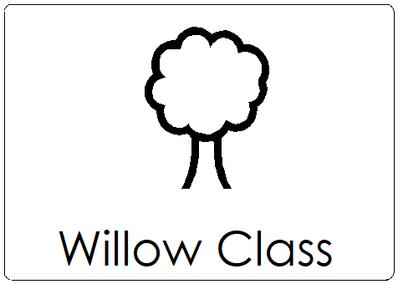
Willow Class Home Learning Guidance

Dear Parents/Carers,
I hope you are well and that your children are settling in to their routines in this challenging time for us all.
I have put together a folder of resources that you could, if you wish, use at home in order to achieve as much continuity as possible with regards to routines and behaviour management as you are able to. Please take what follows as a set of suggestions for things that you could try. They work well in school but may not at home because of the differences between the settings.
These resources include the following things that we use at school and which you could try at home. If you are unable to access Powerpoint or Word, or if you would like me to print anything and send home as hard copies, please let me know and I will endeavour to do so next time I am in school.

- Morning Circle Time Slides (Powerpoint)
These are the circle time slides that we use at the start of every day which you could – if you like – go through with your child on a device. They could give you a chance to:
- Go through your timetable for the day
- Say who is here. In school, we accompany this with a song from Singin’ in the Rain (“Good Morning, Good Morning, it’s good to see you here, Good Morning, Good Morning, to you! Good Morning, to [NAME], it’s good to see you here, Good Morning, Good Morning, to you!”) You could print off pictures of the members of your household to stick on the “Who is here” chart.
- Look at the weather and choose/stick the appropriate symbol.
- Do the ‘Box of the Day.’ For each day we have a multisensory box of things matching the colour of the day. This includes something to look at, something to listen to, something to touch and something to smell. If you have some resources, you could make one of these with your child for each day.
- Practice a ‘Sign of the Day.’ I will send a new ‘Sign of the Day’ Powerpoint slide every day.
- Go through the ‘Good Choices’ which can form a basis for whether you give your child ‘Reward Time Stars.’
- Choose a Reward Time (something that your child can do at the end of the day if they have earned all of their Reward Time Stars) and stick to the end of the chart in the white box.

- Timetable Symbols (Word)
See point 1 above. You should have received a pack in the post with some timetable symbols, but I have included some more in this folder in case you find that any are missing (like the ‘Reward Time’ one which forms a part of the Willow Class routine).

- Who is Here Chart (Word)
See point 2 above.

- Weather Symbols (Word)
See point 3 above.

- Reward Time Charts with Stars and Pictures (Word)
See point 7 above.

- Sticker Charts (Word)
In Willow Class, we give children a sticker at the end of the lesson if they have finished their work. When they have filled their charts with 10 stickers, they are able to have a ‘Dip in the Box’ during the End-of-Day Circle Time (see below). The Dip in the Box includes small stationary and trinkets.

- End-of-day Circle Time Slide (Powerpoint)
This is the routine that we go through at the end of the day and includes:
- Looking at sticker charts and counting stickers
- Doing the Dip in the Boxes if there are any
- Singing a Goodbye Song. We sing ‘This Little Light of Mine’ with an electronic tea light whilst blowing bubbles over the child holding the light. We sing “Shine all over [NAME]” for each person.

- Snack Time Slide (Powerpoint)
This is the slide that we have up during snack time and which you could use on your device during your snack time at home, if you like.

- Behaviour Symbols (Word)
We often show children these symbols to encourage them to do Good Listening, Sitting or Looking when we don’t want to interrupt the flow of the lesson by saying these instructions aloud.

- Lesson Template Slides (Powerpoint)
These slides show the structure that I use to deliver lessons. We always start with a ‘First Work, Then Choosing’ slide before I show pictures of the children’s previous lesson. We then read the learning objective (starting with “I can…”) and then start the lesson. Upon completion of the group activity, I return to the ‘First Work, Then Choosing’ slide and the children start their work. If you would like to use this same system to encourage your child to do some work using the resources mentioned in the pack that you received in the post, it might help to use these slides. It might also help if, upon completion of a work (and subsequent choosing activity), you bring your child back to the ‘First Work, Then Choosing’ slide remind them that they got to do their choosing activity because they finished their work. You can then give them a sticker to place on their chart.

- 5-a-day Login Details (Word)
If you open this Word document you will see a link to a website that we use to do exercise activities every day called 5-a-day. It’s great for encouraging listening to and following instructions, as well as developing gross motor skills. There’s also a section on the site called “Time to Chill” which we use in the afternoon to relax after play time.

I hope that this helps you at home. Please don’t feel that you have to use these resources. They are simply suggestions based on what I have found works for your children at school and may work at home, too. They may also help your child to transition back in to the school routine more smoothly if there has been some continuity at home. I think that some of the most important things for your children at this time of difficulty include predictability and consistency. Achieving this will help to reduce anxiety and facilitate a structure and routine in which they can feel able to engage in meaningful activities.

Please remember that you can contact me via email (when I am working from home or at school) or by ringing the school when I am in. We are currently operating a rota system to allow social distancing by reducing the number of people in the building at any one time, but I this is subject to change.

I hope that you and your children stay safe and well and I very much look forward to seeing you all in person at some point hopefully not too long in the future.

Take care,

Mr Marsden

