Chestnut Home Learning Topic
Flowers and Insects

Suggested Activities and Experiences.
- Start with a nature walk. Go out for a walk and preferably take a camera/ipad to take photos of the flowers, plants and insects you see. (Take paper and pencil to sketch if no camera). Note where the plants and insects are. Are some insects flying, climbing or hiding? Do the flowers like the sunshine or shade? Is the habitat wet, dry, dark or light?

- If you can, print off the pictures to make a collage.

- Explore the idea of things being alive, dead and never alive.
https://www.bbc.co.uk/bitesize/topics/z6882hv/articles/zs73r82

- Gather some objects to put into groups using the symbols (alive, dead and never alive) below as headings eg a pot plant, an animal/insect (can be a picture), a dead leaf, a feather, a coin, stone etc. Extend by making a list of other things that could go in each area.
Through your discussion of which object belongs in which group consider the features of Living Things? (Growth, reproduce, need food and water, they breathe). Does the stone breathe? Etc

- Try growing some seeds in a tray. You can use soil or wet cotton wool or tissue and preferably fast-growing seeds like cress, herbs, grass. Make a cone with dark card and cover an area of the seed tray. Keep the whole of tray moist. Ask children to predict what will happen? Take a look every couple of days to see what changes they notice. They can take photos, draw or even use voice notes on a device to record observations. Help children to understand that plants need light.

- Try a similar experiment with 2 eggshells. Draw smiley face on one and sad face on the other, put moist cotton wool/tissue in smiley egg and dry in the sad egg. Put both in sunny position. Keep smiley egg watered. What do they observe? They can take photos, draw or even use voice notes on a device to record observations. Help children to understand that plants need water.

- To explore how flowers ‘drink’ try putting daisies into a small glass of water and food colouring. Observe what happens.

- Talk about parts of a flower.
https://www.youtube.com/watch?v=ql6OL7_qFgU
This is nice and quite straightforward and fun to get involved.
https://www.bbc.co.uk/teach/class-clips-video/science-ks1-ks2-ivys-plant-workshop-the-anatomy-of-the-flower/zjmhkmn
This is a bit more detailed if you want to extend the learning.

- Complete the twinkl worksheets saved on Chestnut area on website. One to name basic parts of a flower and one to cut out the parts and rebuild and stick down. There is also a more detailed flower labelling activity.

- Talk about how living things reproduce. Have a go at these baby animal puzzles.
https://www.bbc.co.uk/games/embed/gjwd1bxmm7?exitGameUrl=https%3A%2F%2Fwww.bbc.co.uk%2Fcbeebies%2Fpuzzles%2Fandys-baby-animals-jigsaw

- Read ‘The Tiny Seed’. https://www.youtube.com/watch?v=ls6wTeT2cKA
Show some seeds in real life eg apple pips, strawberry seeds, dandelions etc. Have a go at growing beans in a jar with absorbent paper and cotton wool so children can observe the germination process. Children can keep a diary of their observations. You can use any dried bean. They may not grow into amazing plants but should germinate and grow enough for this task.

- Read ‘A Very Hungry Caterpillar’. https://www.youtube.com/watch?v=75NQK-Sm1YY
Talk about the life cycle of a butterfly. https://www.natgeokids.com/uk/discover/animals/insects/butterfly-life-cycle/
You can have a go at making these paper plate butterfly life cycles. There are loads of examples online including this one.
https://buggyandbuddy.com/butterfly-life-cycle-craft/

- Watch clips of ‘Antz’ or ‘A Bugs Life’ What insects/minibeasts do they know already? Make a list

- Complete the minibeast cutting and sorting activity saved on Chestnut area of the website.
- Explore and research the life of ants.
https://www.nationalgeographic.com/animals/invertebrates/group/ants/
https://www.youtube.com/watch?v=S7QiQPtKN9k
https://pestworldforkids.org/pest-guide/ants/
Have a go at these ant craft activities which highlight the 3 main parts of the ant’s body, head, thorax and abdomen.
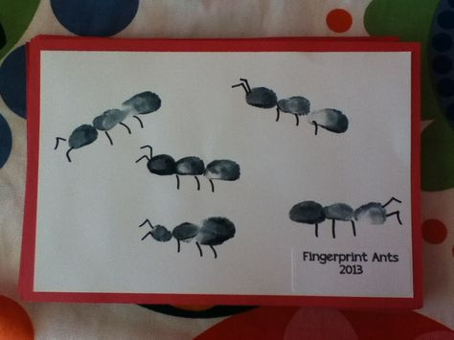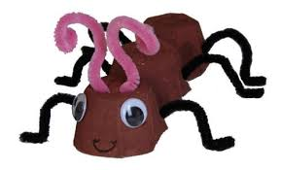
Finger print ants. Egg carton ant.

- Take a look at this video about bees.
https://www.youtube.com/watch?v=ta154f5Rp5Y
Try some honey. If you are lucky and have more than one jar of honey you could have a honey taste test and choose a favourite.
Try a pollination experiment to show how a bee pollinates different plants. There are a few online including this one.
https://jdaniel4smom.com/2015/04/fun-science-experiments-pollinatation.html

- Try a kahoot quiz all about plants and insects.

- Show the children examples of work by famous artists and/or sculptors who have represented flowers or insects in their work. The following pieces will provide a useful starting point:
Poppies Blooming, 1873; The Artist’s House at Argenteuil, 1873 by Claude Monet
Sunflowers, 1888; Irises, 1889 by Vincent Van Gogh
Moebius Strip 1963; Butterflies II, 1950 by Maurits Cornelis Escher
Choose their favourite picture. Why do they like it?
Children to create a flower picture with paint, chalk or crayons. Children can find a flower to copy while on a walk.

Topic Finale

- Make a miniature garden on a tray. You can use a range of living and non-living things to create your garden. You can have a go at designing it first thinking about all the things plants and insects need in a garden. What would they like to have in their garden? Explore gardening magazines and examples of other miniature gardens to get ideas. You can make little signs and labels. We would love to see examples of these. Here are a few examples.

