Numeracy – Number
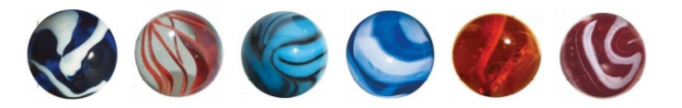

1.a. How many marbles are there?...................................................
1b. Draw 5 marbles

2.a. Complete the table
Words | Digits
………………………………… | 7
twelve | …………………………………

3. Look at the list of numbers.
4 7 9 0 17
3.a. What is the smallest number?...............................
3.b. What is the largest number? …………………………
4.a. Fill in the missing numbers:

7 8 ……… 10

18 17 ……… 15
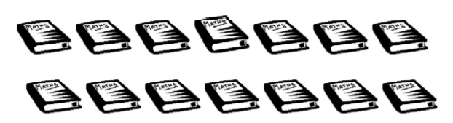
5.

How many books are there? …………………………….

6. Write the following numbers in order starting with the smallest:
7 20 11 6 2

………………………………………………………………………
7. Here are some test marks for four students.
Molly Emily Jacob Nick
57 62 39 60
7.a. Who scored the most marks?...............................
7.b. Who scored the fewest marks?...........................
7.c. Steve also took the test, he scored more than Nick but less than Emily. What was his score?...........................
8.a. What is the value of the digit underlined?
57 ……………
68 ……………
9. Look at these numbers.
7 33 64
22 45
Circle the odd numbers.

10. Write down 2 even numbers between 21 and 31.
………………………………………

11. Round 64 to the nearest 10.
…………………………

12. Here is a counting pattern. Fill in the missing numbers.
15 20 ……… 35 40 ……… 50

13. Write the following numbers in order, from smallest to largest.
79 52 128 25 218 97

……… ……… ……… ……… ……… ………

14. Kyle has 54 football cards.

14.a. Amy has 14 fewer cards than Kyle.
How many cards has Amy?......................

14.b. Will has 100 more cards than Amy.
How many cards has Will?.....................

15. Look at the following words and put them in the correct column.
subtract plus difference less total fewer
add minus take-away combined decrease
left more increase sum together change
-
…………………… ……………………
…………………… ……………………
…………………… ……………………
…………………… ……………………

…………………… ……………………
…………………… ……………………
…………………… ……………………
…………………… ……………………

