Numeracy – Mental Maths
The following is simple guide on how to access online maths games with additional information/advice on how you can support your children.
Go to the website: https://www.topmarks.co.uk
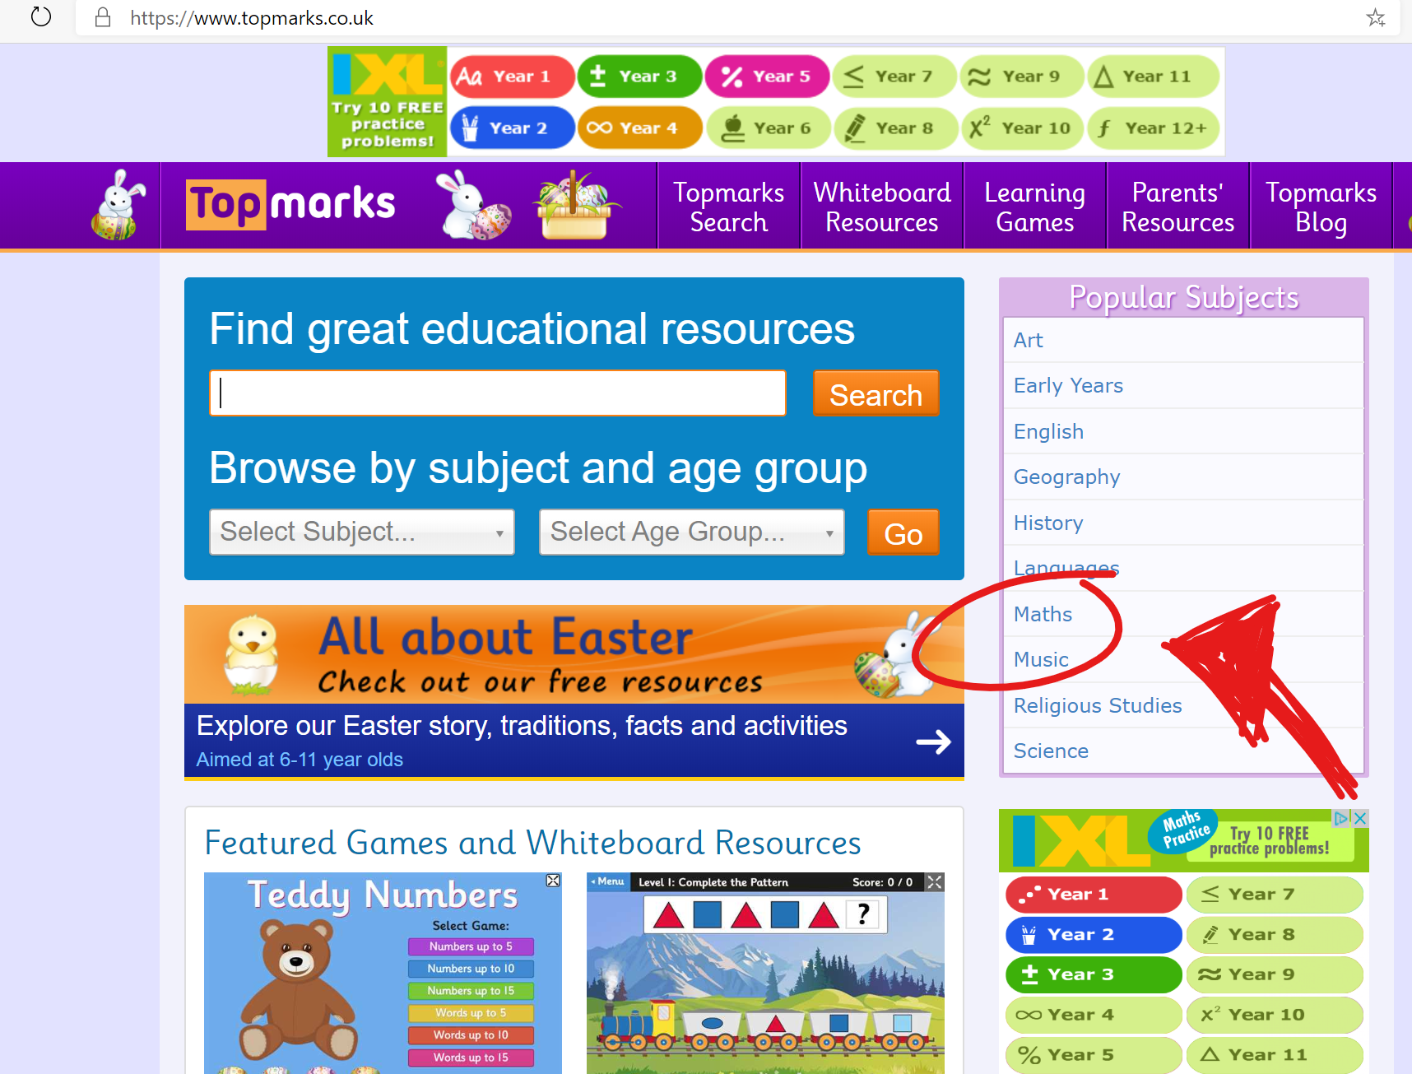

…Then click ‘Maths’

Which takes you to here…
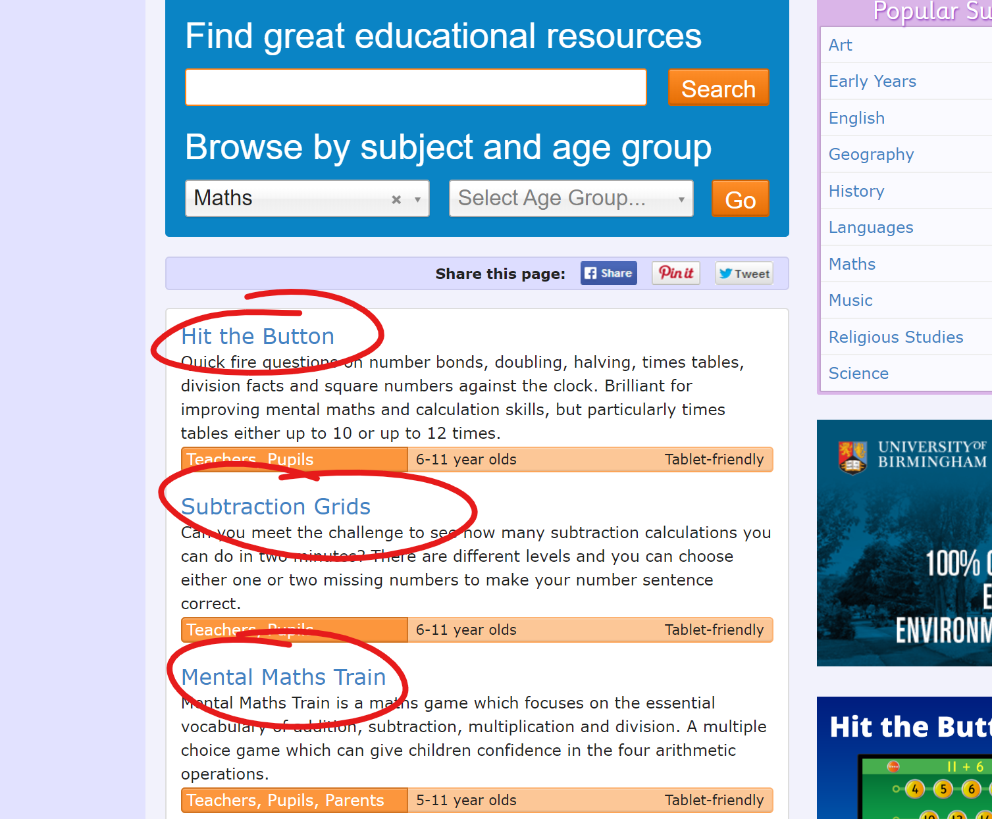
Where you will see a list of fantastic interactive Maths games.
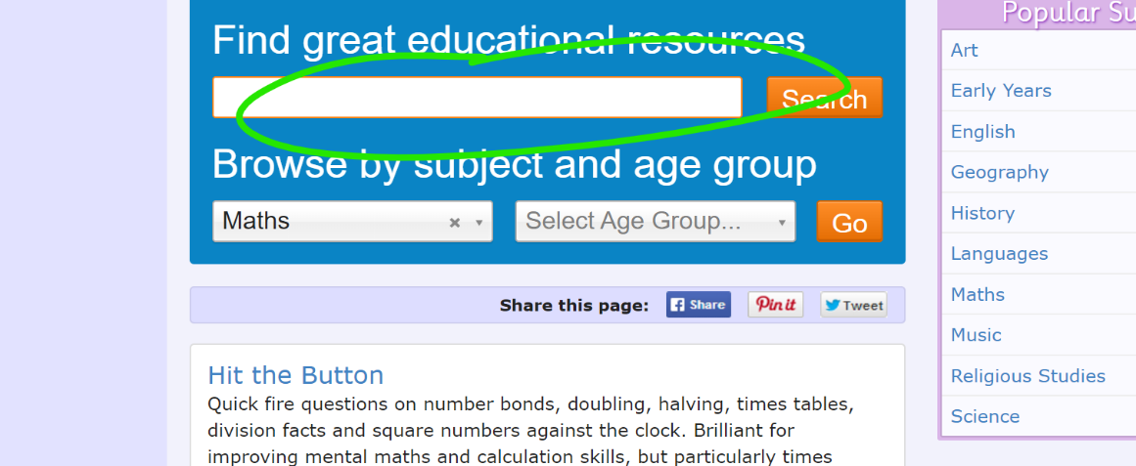
Below I have created a list of the best games, with a brief description of what skill they are practising, just type the one you want into the resource search and off you go.

Straight Forward Games
‘Alien Addition’ – Adding
‘Minus Mission’ – Subtraction
‘Blast Off’ – Adding, Subtraction, Number Recognition (spoken instructions)
‘Caterpillar Ordering’ – Place Value/Ordering and Sequencing
‘Rocket Rounding’ – Rounding to nearest 10/100
‘Measuring in cm’ – Using a ruler
‘Teaching Clock’ – Practising telling times(Digital and Analogue)

Trickier Games (Higher Level Skills)
‘Maths Invaders’ – Addition/Subtraction/Multiplication/Reading Numbers (words and digits)/Fractions
‘Maths Fishing’ – Multiplication (including decimals)
‘Colouring Numbers in Pascal’s Triangle’ – Division (including large numbers)
‘Countdown’ – Addition/Subtraction/Multiplication/Division

*NB*: This is also a great opportunity for times tables practise. Set a target of one set per week.
The recommended order is: 2x, 5x, 10x, 3x, 4x, 6x, 7x, 8x, 9x…then potentially 11x & 12x.

