Reading Task 1
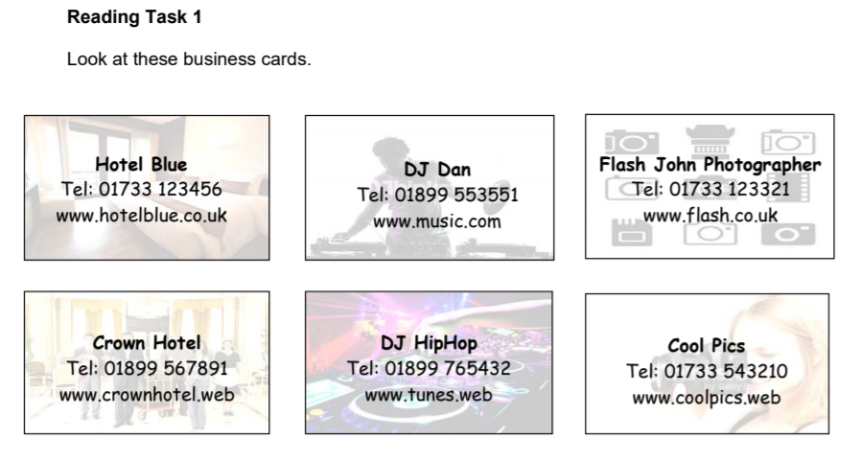

1. Look at the list of companies above and use the information to fill in the table below.
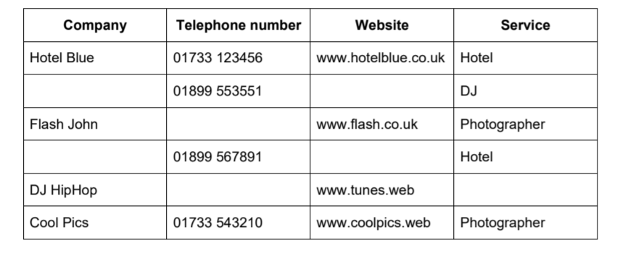
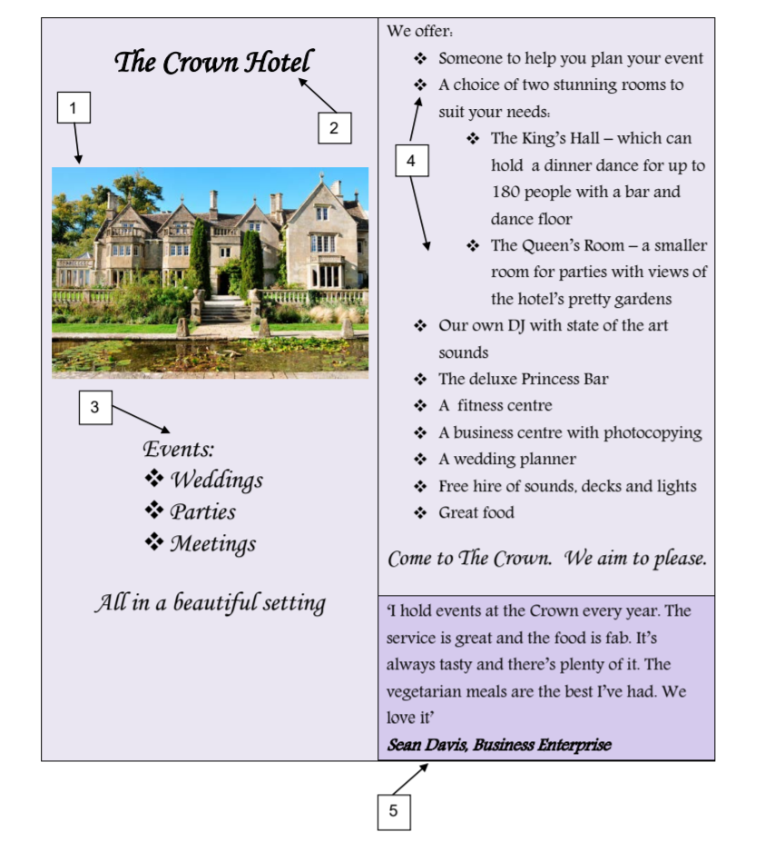
Reading Task 2

1. Match the numbers on the advert to the descriptions in the table below. One has been done for you.

2. What makes the hotel a good place to hold the prom? Fill in the table below. One has been done for you.
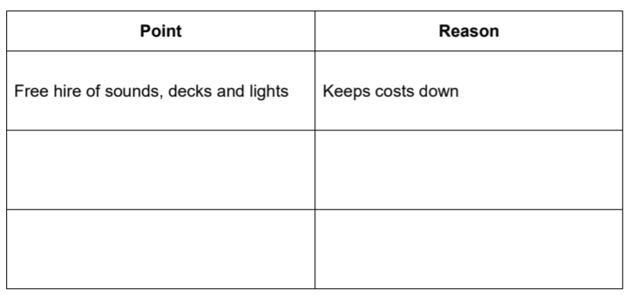

………………………………………………………………………………………………………………………………………………………………………………………………………
…………………………………………………………………………………………………………………………………………………………………..
…………………………………………………………………………………………………………………………………………………………………..
………………………………………………………………………………………………………………………………………………………………………………………………………

3. Explain why the hotel has used these phrases in their advert. One has been done for you.
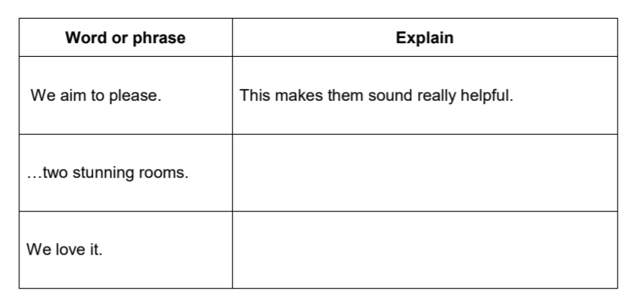
…………………………………………………………………………………………………………………………………………………………………………………………………………………....
…………………………………………………………………………………………………………………………………………………………………………………………………………………..

4. Would you like to have a prom at the Crown Hotel? Give your reasons based on what you have read in the hotel advert.
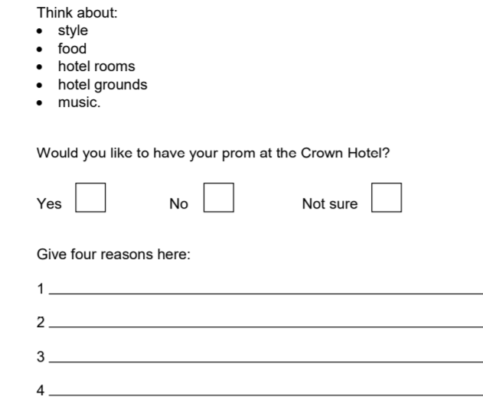

Reading Task 3
Look at this email from a student who went to last years prom.
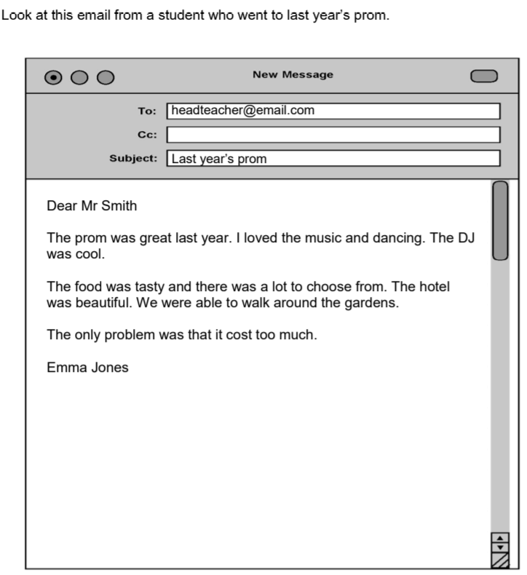

- Explain why Emma used these words in her email. One has been done for you.

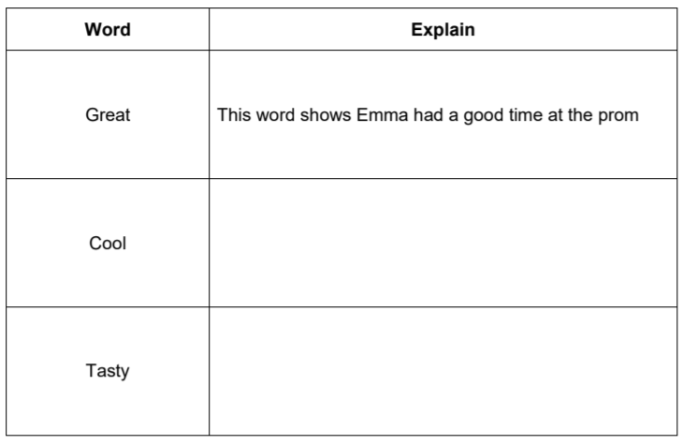
……………………………………………………………………………………………………………………………………………………………………………………………………………………………………………………………………………………………………………………………………………………………………..
……………………………………………………………………………………………………………………………………………………………………………………………………………………………………………………………………………………………………………………………………………………………………..

Writing Task
Your task is to now create ideas for your own prom. Use the table underneath to structure your ideas.
Remember:
- Capital letters and full-stops
- Full sentences
- Be careful with spelling
